Monthly Performance Report – July 2026
Kestrel Ridge Wind Farm (75.6 MW)
David Chen · 09 August 2026 · KR-OPS-RPT-2026-07

1. Summary
Kestrel Ridge generated 9.8 GWh in July 2026, 10.1 % below the P50 budget of 10.9 GWh. Time-based availability was strong at 97.6 % (contract target 97.0 %). Mean hub-height wind speed of 6.4 m/s was close to the long-term mean (6.6 m/s). Compared with July 2025 (10.3 GWh), output was down 0.5 GWh.
A shadow flicker complaint from a resident at Netherhall Cottage (receptor R4) was investigated; the T-15 shadow flicker module had lost its time synchronisation and was corrected on 9 July.

2. Production and key figures
KPI | July 2026 | Budget / target | YTD 2026 | YTD budget
Net generation (GWh) | 9.8 | 10.9 | 116.6 | 121.0
Time-based availability | 97.6 % | 97.0 % | 96.8 % | 97.0 %
Capacity factor | 17.4 % | 19.4 % | 30.3 % | –
Mean wind speed at hub height (m/s) | 6.4 | 6.6 | – | –
Source: Kestrel Ridge SCADA, revenue meter at 132 kV point of connection. Budget = P50 (2024 post-construction yield assessment).
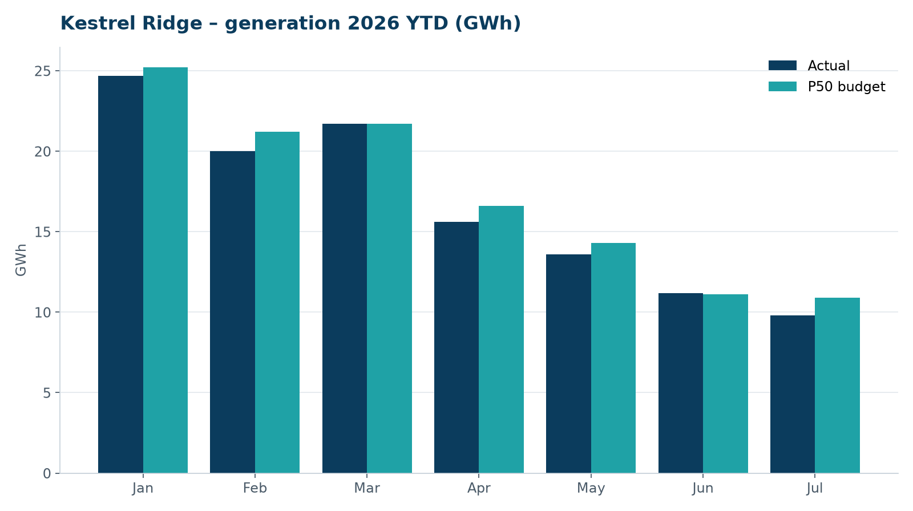
Monthly generation vs. P50 budget, 2026 year to date

3. Availability and downtime
Total turbine downtime attributable to the contractor amounted to 43 turbine-hours for the top events listed below. No grid or force majeure exclusions were claimed this month.
Turbine | Event | Downtime (h)
T-17 | nacelle cooling fan motor failure | 17
T-18 | hydraulic oil leak at rotor brake caliper | 13
T-18 | pitch motor encoder fault on blade C | 9
T-06 | service lift fault – lift locked out, turbine stopped for rescue cover | 4
Top downtime events of the month (SCADA event log, reviewed with Highline Wind Services).

4. Maintenance
- Annual service: 3 turbines completed this month.
- 14 corrective work orders closed, 6 still open at month end.
- Gearbox oil samples taken on six turbines as per the quarterly rota; results within limits.

5. Health, safety and environment
Indicator | Month
Hours worked on site (Highline + Weyland) | 4,456
Lost time injuries | 0
First aid cases | 0
Near misses reported | 0
Safety observations | 6
Environmental incidents | 0

No environmental incidents. Bird carcass searches were carried out on schedule (fortnightly, all turbines).

6. Outlook
The P50 budget for next month assumes normal seasonal wind; no planned outages beyond routine maintenance.
Prepared by Sara Lindgren (Performance Analyst); reviewed by Ben Okoye (Site Manager) and David Chen (Asset Operations Manager).

